ZNP 4/2024

**Verbandsnachrichten der Gesellschaft für Neuropsychologie Österreich (GNPÖ)**

**Über die GNPÖ**

Als größtes österreichisches Netzwerk der Klinischen Neuropsychologie sowie als Berufsvertretung ist die GNPÖ österreichweit der langjährigste und qualitätsvollste Bestanbieter für Fort- und Weiterbildung in Klinischer Neuropsychologie. Unser umfassendes Seminar-Angebot ist international beständig und rechtssicher, die hochkarätigen Referent:innen sind nationale und internationale Expert:innen auf ihrem jeweiligen Fachgebiet. Zudem bieten wir Zugang zu Österreichs modernstem und umfassendstem Weiterbildungscurriculum in Klinischer Neuropsychologie.

Als Organisation sind wir ein Non-Profit-Unternehmen und verwenden moderne und professionelle Strukturen und Prozesse. Klar, selbstbewusst und zukunftsweisend bieten wir unseren Mitgliedern und allen Interessierten permanenten Zugriff auf den letzten Wissensstand der Klinischen Neuropsychologie und vermitteln ihnen damit ein sicheres Gefühl für ihren klinischen Alltag. Unser Fokus liegt einerseits auf einer kundenorientierten und kompetenten Beratung unserer Mitglieder und andererseits auf EU-konformer und international beständiger Qualitätsarbeit. Besuchen Sie uns auf www.gnpoe.at

* 1. **Intern**

**Unsere Absolvent:innen**

Im Zeitraum vom 22. Juli 2024 bis zum 14. Oktober 2024 erhielt folgende Kollegin das Zertifikat über die Weiterbildung in Klinischer Neuropsychologie gemäß den Kriterien zur Spezialisierung lt. §29 PG 2013:

Mag. Dr. Carina Maria Tiewald

Wir beglückwünschen sie zum abgeschlossenen GNPÖ-Weiterbildungscurriculum und wünschen ihr für die weitere persönliche und berufliche Laufbahn alles Gute!

**GNPÖ-Fortbildungsakademie**

Ein erfolgreiches Jahr 2024 geht zu Ende, in welchem unsere Fortbildungsakademie viele exzellente Seminare veranstalten und führende Expert:innen ihres Fachgebietes begrüßen durfte. Auch für das kommende Jahr wurden bereits zahlreiche Veranstaltungen geplant, darunter viele neue Inhalte und Vortragende, sodass auch fleißige Seminarbesucher:innen im Jahr 2025 auf ihre Kosten kommen werden. Unser bewährtes System der Paketangebote bleibt weiterhin bestehen, bei welchen inhaltlich nahe Seminare zu einem vergünstigten Paketpreis gebucht werden können. Auch fix verankert im Seminarplan 2025 ist die neuropsychologische Supervision, welche traditionellerweise am ersten Mittwoch im Monat stattfindet und entweder Themen aus dem Erwachsenenbereich oder dem Kinder- und Jugendbereich behandelt. Für nähere Informationen bzw. den vollständigen Seminarkalender besuchen Sie unsere Homepage unter <https://gnpoe.at/seminare>.

* 1. **National**

**Neuropsychologie im Frühling – Save the date**

Bereits zum zweiten Mal findet am 08. Mai 2025 das Symposium „Neuropsychologie im Frühling“ in Kooperation mit der Österreichischen Akademie für Psychologie (ÖAP) statt. Unter dem Arbeitstitel „Der Mehrwert der Klinischen Neuropsychologie in der Psychiatrie“ werden Expert:innen eingeladen, um ihr Fachwissen an der Schnittstelle zwischen Neuropsychologie und Klinischer Psychologie an die Teilnehmer:innen weiterzugeben. Anmeldungen für dieses Online-Event können auf der Homepage der ÖAP getätigt werden.

* 1. **International**

**Gelebtes Memorandum of Understanding – 26. Jahrestagung der GNPÖ in Kooperation mit der GNP**

Am 04. und 05. Oktober 2024 war es soweit; der Höhepunkt des neuropsychologischen Jahres, die 26. Jahrestagung der GNPÖ, wurde im Wiener Musikverein abgehalten.

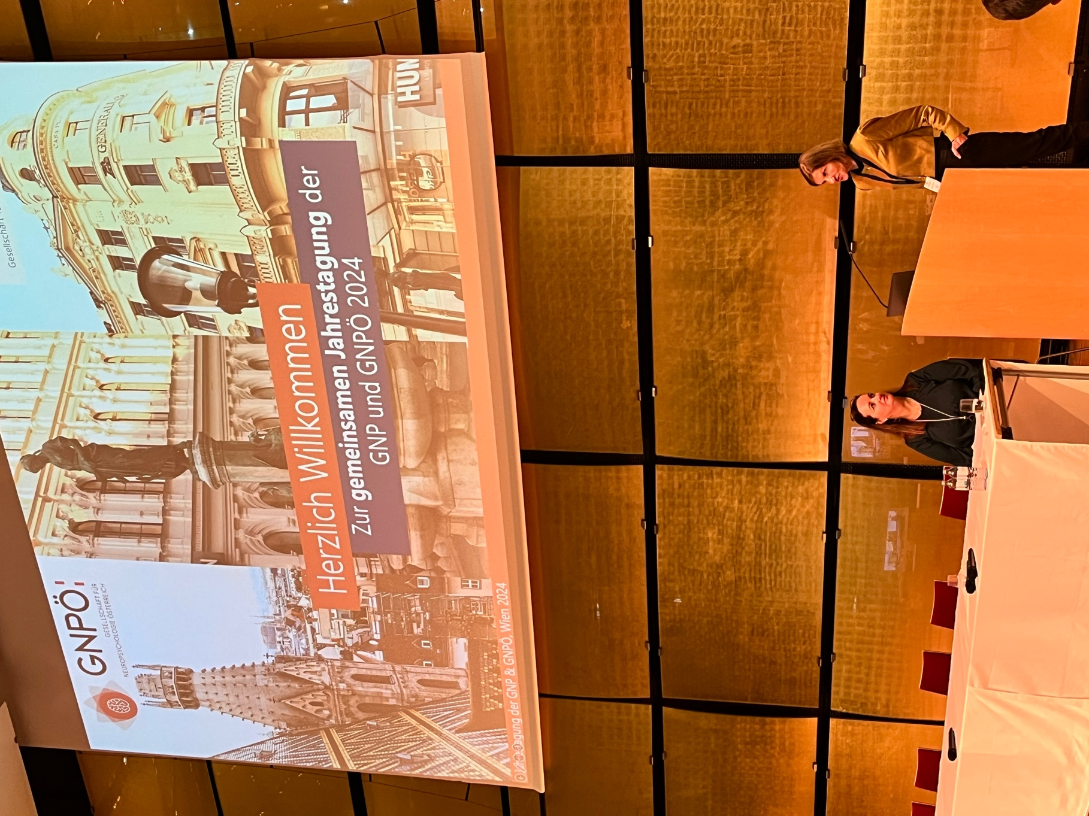Mag.a Dr.in Sandra M. Lettner und Dipl.-Psych.in Sabine Unverhau bei der feierlichen Eröffnung der internationalen Fachtagung.

Acht Jahre nach der 3-Ländertagung in Würzburg im Jahr 2016 und nur ein Jahr nach der feierlichen Unterzeichnung des Memorandums of Understanding, einem Vertrag zwischen der deutschen und der österreichischen Gesellschaft für Neuropsychologie in Hinblick auf berufspolitische sowie organisatorische Zusammenarbeit, ist es gelungen, eine gemeinsame Veranstaltung mit dem Titel: „Neuropsychologie gemeinsam weiterdenken“ zu organisieren.

Beide Gesellschaften zeichneten sich für die Programmgestaltung gleichermaßen verantwortlich und es wurde versucht, auch inhaltlich dem Titel der Veranstaltung gerecht zu werden. In zwei herrlichen Sälen (Gläserner Saal und Brahms Saal) des Wiener Musikvereins wurde in 10 Symposien neben „klassischen“ Themenbereichen der Klinischen Neuropsychologie wie ADHS, Lesen- und Leseprobleme, Multiple Sklerose, Fahreignung (inkl. Fahrzeug zur Überprüfung der Fahreignung, welches vor dem Musikverein geparkt war) oder neuropsychologische Interventionen ein besonderes Augenmerk auf neue Forschungs- und Anwendungsfelder der Neuropsychologie wie Sportneuropsychologie oder die Digitalisierung in der Neuropsychologie gelegt. Namhafte Kolleg:innen aus Österreich (Mag. Dr. Schöfl, Priv.-Doz.in Mag.a Dr.in Kaufmann) sowie Deutschland (Dipl.-Psych.in Unverhau, Dr. Dipl.-Psych. Vohn, Dipl.-Psych.in Golz, PD Dr. Töpper, Prof.in Dr.in Müller, Dr.in Randerath) konnten in ihrer Funktion als Chairs spannende und neuwertige Beiträge aus Wissenschaft und Klinik aus ihrem Arbeitsfeld bieten.

Auch konnten zwei hochkarätige Key Note Speaker gefunden werden: Prof. Dr. Roi Cohen Kadosh, Professor an der Oxford University am Department of Experimental Psychology, präsentierte aktuelle Forschungsergebnisse aus dem Bereich der Neurostimulation und Prof. Dr. André Zimpel, Professor an der Universität Hamburg an der Fakultät für Erziehungswissenschaften, referierte über Neurodiversität.

Im Rahmen der Fachtagung fanden auch die Generalversammlungen beider Gesellschaften mit den jeweiligen Neuwahlen des Vorstandes statt. Wir freuen uns sehr, dass der Vorstand der GNPÖ in der bestehenden Konstellation wieder gewählt wurde, und bedanken uns herzlich für Ihr Vertrauen!

Den feierlichen Abschluss des ersten Vortragtages bildete der Gesellschaftsabend. Für die internationalen Speisen auch während der Tagung sorgte der heimische Caterer „Speisen ohne Grenzen“, eine gemeinnützige Initiative zur Integration geflüchteter Menschen.

Danken wollen wir auch den zahlreichen studentischen Helfer:innen, darunter auch die Mitglieder unserer Fachgruppe Klinische Neuropsychologie für Studierende, welche sowohl die Vortragenden als auch die Teilnehmer:innen tatkräftig unterstützt haben.

Last but not least gebührt unseren Sponsoren HelferApp, Schuhfried, Hogrefe sowie Hasomed Dank, denn ohne ihre finanzielle Unterstützung gäbe es keine Jahrestagung.

Aus unserer Sicht konnten, entsprechend des Tagungstitels, Brücken gebaut werden. Es gab einen regen Austausch zwischen Wissenschaft, Klinik und Industrie, aber auch zwischen den einzelnen Mitgliedern beider Gesellschaften und insbesondere beider Vorstände. Wir hoffen auf eine weitere enge und inspirierende Zusammenarbeit!

Nach der Jahrestagung ist vor der Jahrestagung: bitte halten Sie sich im kommenden Jahr wie gewohnt das erste Oktoberwochenende für die 27. Jahrestagung der GNPÖ frei.

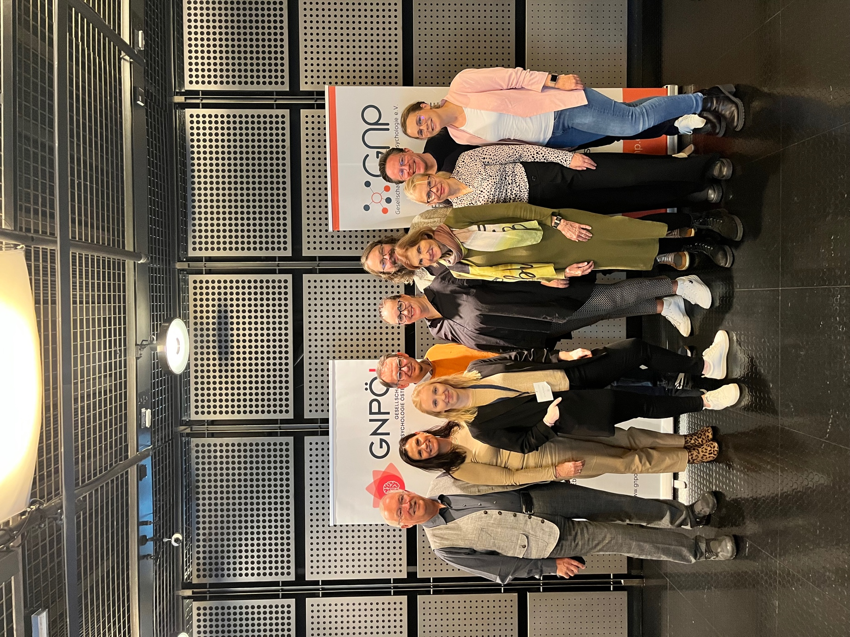

„Neuropsychologie gemeinsam weiterdenken“ – Die Vorstandsmitglieder der GNPÖ zur Linken und die Vorstandsmitglieder der GNP zur Rechten.

**Science Slam und die Verleihungen des Giselher-Guttmann Preises 2024 und des Wilhelm-Strubreither Preises 2024**

Wie jedes Jahr wurden im Rahmen der GNPÖ-Jahrestagung die besten Nachwuchswissenschaftler:innen österreichischer Universitäten zum alljährlichen Science Slam geladen, um aus ihren Reihen die Preisträger:innen des Giselher-Guttmann-Preises 2024 für wissenschaftliche Arbeiten im Bereich der Grundlagenforschung sowie des Wilhelm-Strubreither-Preises 2024 für Arbeiten im Bereich der angewandten Forschung zu küren. Die Finalist:innen der beiden Preise durften ihre Arbeiten auf der Jahrestagung im Rahmen des Science Slams, welcher von Ass.-Prof.in Priv.-Doz.in Dr.in Laura Zamarian, PhD moderiert wurde, in einem jeweils dreiminütigen Pitch präsentieren. Nach dem traditionalen Ständchen für Prof. Giselher Guttmann anlässlich seines 90. Geburtstages sowie der Überreichung der „Tiroler Prügeltorte“ wurden die beiden Preisträger:innen verkündet. Wir gratulieren Frau Claudia Massaccesi ganz herzlich zum Giselher-Guttmann-Preis 2024 und Frau Isabel Bauer zum Wilhelm-Strubreither-Preis 2024! Beide Preise sind in der Höhe von jeweils 1.000,- Euro dotiert. Auch jenen Kolleg:innen, deren Arbeiten es jeweils auf den zweiten und dritten Platz geschafft haben, dürfen wir sehr herzlich für Ihre Leistung gratulieren. Die Abstracts der Arbeiten aller Finalist:innen sind nachstehend veröffentlicht.



Science Slam Preisverleihung, untere Reihe (von links nach rechts): Claudia Massaccesi, Giselher Guttmann, Wilhelm Strubreither, Isabel Bauer

Obere Reihe (von links nach rechts): Sandra M. Lettner, Mohamed Ameen, Elisabeth Göttfried, Laura Zamarian

**Abstracts zur Ausschreibung des Giselher-Guttmann-Preises 2024 (alphabetisch nach Erstautor:in geordnet)**

**The Interplay between Information Processing and Memory Consolidation during Sleep: a break to clean and re-organize.**

Ameen, M. S.

Far from being a passive state, sleep involves complex brain functions that maintain a connection to the environment while focusing on consolidating important memories. For these two important yet opposing processes to occur without conflict, a protective mechanism must exist. This thesis explores the complex balance between external and internal processing mechanisms in the sleeping brain. Through high-density electroencephalography (EEG) and intracranial EEG (iEEG), the research presented in this thesis investigates the interplay between these dual roles across three key studies.

The first study examines how the brain selectively responds to auditory stimuli during non-rapid eye movement (NREM) sleep. The findings reveal that the brain discriminates between familiar and unfamiliar voices, with unfamiliar voices triggering more pronounced arousal responses and K-complexes, all while maintaining and protecting sleep from major disruptions. Thus, our first study provides evidence for the presence of an adaptive mechanism to maintain sleep while staying alert to potentially significant environmental changes. The second study addresses the role of sleep in the consolidation of memories in the context of motor adaptation, specifically the consolidation of procedural memories associated with a novel motor task—typing on a mirrored keyboard. Results demonstrate that sleep enhances motor adaptation, with significant modulation observed in fast sleep spindles, particularly in light sleep, followed by a modulation of beta oscillations upon awakening. This supports the hypothesis that sleep not only stabilizes but also optimizes newly acquired motor skills through coordinated neural activity. The third study shifts focus to the temporal dynamics of brain activity during sleep using aperiodic brain activity as a model. By employing time-resolved analysis of EEG and iEEG data, this research uncovers that variations in the spectral exponent and the presence of 'knees' in the power spectrum are indicative of changes in the level of consciousness, i.e. sleep stages and consequently the switch between phases of internal and external processing. Moreover, the temporal properties of such change imprints for the dynamics of transition between stages in the time domain. These findings provide new insights into the temporal patterns of sleep architecture and the potential utility of aperiodic activity in detecting different processes during sleep and consequently in refining sleep staging.

This thesis proposes that the sleeping brain can dynamically shift between internal processing and external awareness with a central role for sleep microstructure in achieving such balance. The research not only deepens our understanding of the neural mechanisms of sleep but also introduces innovative methodologies for brain activity analysis, with direct implications for improving the diagnosis and treatment of sleep-related disorders, paving the way for more targeted and effective interventions.

**Mu desynchronization during motor imagery: A potential marker of imagery ability?**

Etzler, A.

Aim: Investigating EEG mu desynchronization (8-13 Hz) during motor imagery (MI) of a grossmotor-sequence task as a potential marker of imagery ability and sleep-related performance gain.

Design: 31 younger (*M* = 22.2, *SD* = 2.54, 19 females) and 9 older adults (*M* = 70.7, *SD* = 3.91, 8 females) were tested over 7 days, including two nights of ambulatory polysomnography. Participants learned a sequential footstep task, either in the morning (AM-group) or in the evening (PM-group). Following the training participants of the MI-group practiced the sequence via MI, while the control-group listened to an audiobook. Physical performance was tested before (pre-test) and after MI/audiobook (post-test 1) and retested 12 (post-test 2) and 24 hours (post-test 3) later, followed by a second MI-session within the MI-group. EEG activity was recorded throughout all sessions. Mu desynchronization was computed as a decline in spectral mu power during MI compared to mu power during rest. MI-ability was assessed via questionnaires.

Results: Mu desynchronization during MI was strongest over parietal sites. Only subjects in the MI-group practicing in the evening increased their performance from post-test 1 to post-test 3 (*t*(25)=-6.79; p<.001). Mu desynchronization during the second MI correlated positively with sleep-related performance gain (*ρ*(13)=.45; p=.094). Both, immediate (*ρ*(13)=.55; p=.034) and delayed motor performance gain (*ρ*(13)=.58; p=.03) correlated with kinesthetic MI ability of the second MI session.

Conclusion: MI-training, accompanied by parietal mu desynchronization, promotes performance gain, especially when followed by sleep compared to wakefulness. Results suggest that improvements in physical task execution benefits task imagery ability and can be reflected in changes of the EEG mu rhythm during MI.

**Shining Light on the Modulation of Brain Electrophysiology during Sleep and Wakefulness**

Höhn, C.

Recent research has highlighted the potential of non-oscillatory EEG features that have often been disregarded as noise but may offer insights into our understanding of brain functioning, even though it is not clear yet how these markers are modulated across different brain states during sleep and wakefulness and how or to what extent they are related to another. Furthermore, it is well-known that brain activity and circadian rhythms are modulated by environmental stimuli, with light, particularly short-wavelength light, being the primary modulator. Research has shown that artificial evening light exposure can affect melatonin secretion, sleep-wake regulation, and brain activity, which presents a significant challenge for modern society. However, the utility of blue-light filters and potential developmental differences regarding the effect of short-wavelength light are still unclear.

For this dissertation, a comprehensive study was conducted, involving four laboratory polysomnography nights per participant. Data from 68 male participants (33 adolescents; 15.42 ± 0.97 years and 35 adults; 21.51 ± 2.06 years) were collected and multiple cognitive tasks as well as a 90min light exposure session were scheduled on three laboratory nights. Within this study, the role of non-oscillatory EEG measures for understanding electrophysiological brain activity changes during sleep and wakefulness and the effects of evening short-wavelength light emitted by a smartphone with or without a blue light filter were assessed.

As arguably the two most popular non-oscillatory EEG features, spectral slope and Lempel-Ziv complexity were assessed with regard to their capacity to differentiate between different tasks and sleep stages and it was determined how narrow- (30 – 45Hz) or broadband (1 – 45Hz) frequency ranges affect these parameters. The results showed that, while both measures reliably differentiated between tasks and sleep stages, the narrowband slope provided more information by further predicting attentional task performance. Additionally, it was found that reading on a smartphone for 90min during the late evening significantly suppressed melatonin secretion, with this effect lasting longer in adults than in adolescents, who recovered significantly quicker. Using a blue light filter proved to be partially effective as it mitigated additional disruptive sleep effects of the smartphone usage that were present in adults but not in adolescents. While the use of smartphones resulted in a significant reduction of early slow-wave sleep in adults, sleep-dependent memory consolidation and the coupling between slow oscillations and sleep spindles were fully preserved in both age groups.

By using an extensive study design, this research demonstrated that non-oscillatory EEG markers hold promise for future brain state classifications and underpinned the importance of adhering to sleep and light hygiene recommendations while accounting for age-specific differences in light sensitivity.

**Effects of dopamine and opioid receptor antagonism on the neural processing of social and non-social rewards**

Massaccesi, C., Korb, S., Götzendorfer, S., Chiappini, E., Willeit, M., Lundström, J. N., Windischberger, C., Eisenegger, C., Silani, G.

Rewards are salient stimuli driving human behavior to promote well-being and survival. Dysregulation of reward processing is a hallmark of several psychopathologies, highlighting the importance to better understand its neurobiological basis. While extensive animal research indicates the existence of partially segregated neurochemical systems – the opioid and dopamine systems – behind wanting (the motivation to pursue a reward) and liking (the pleasure associated with its consumption) of primary rewards (e.g., food), less is known in humans, especially when considering different types of rewards, such as those of social nature. In the present study, we investigated if this segregation extends to the human reward system and if social and non-social reward processing rely on the same neuroanatomical and neurochemical circuitry.

We combined functional magnetic resonance imaging (fMRI) and pharmacology to investigate the effects of dopamine and opioid receptor antagonism on the neural processing of social and non-social rewards. Specifically, using an ad-hoc experimental paradigm with high translational value, we assessed brain activity during the anticipation and experience of interpersonal touch (caresses to the forearm; social reward) and palatable food (chocolate milk; non-social reward), after administering either the non-selective opioid receptor antagonist naltrexone, the D2/D3 dopamine receptor antagonist amisulpride, or placebo, in a randomized, double-blind, between-subject design (N = 89).

While at the behavioral level no drug effect was observed, brain activity was modulated by the administered compounds. In particular, opioid antagonism, compared to placebo, reduced activity in the medial orbitofrontal cortex, a crucial reward hub, during consumption of the most valued social and non-social rewards. Contrary to our hypothesis, dopamine antagonism had no effects on brain activity during reward anticipation, while it affected activity in sensory and motor processing regions during consumption.

In conclusion, by leveraging pharmacology, neuroimaging, and a translational experimental paradigm, we showed reduced liking-related activity in the medial orbitofrontal cortex following opioid blockade during the receipt of food and social touch. This indicates a common opioidergic mechanism underlying the neural representation of the hedonic value of social and non-social rewards. The findings represent a significant step toward deepening our understanding of the neurochemical and neuroanatomical foundations of human reward wanting and liking. This research also holds promise for a better comprehension of clinical conditions characterized by general disturbances in reward processing, such as anorexia nervosa and depression.

**Neural Synchrony, Behavioral Dynamics and Attachment in Infancy**

Pointner, N., Hoehl, S. & Nguyen, T.

From birth, infants actively engage in interactions, allowing them to acquire social competence (Ilyka et al., 2021) and form social bonds with close others, such as their caregivers (Feldman, 2017). Starting at three months of age, dyadic interactions between infants and their caregivers are characterized by reciprocal coordination (Beebe et al., 2010). This observable coordination, defined as temporal alignment of behavioral and biological signals between interaction partners, is also known as interpersonal synchrony (Feldman, 2012). Interpersonal synchrony, however, is a dynamic process that varies in its degree of regularity. Irregularity or variability within synchronous periods is referred to as entropy (Fusaroli et al., 2014). High entropy indicates a less repetitive and more fluctuating coordination pattern between the interaction partners, resulting in higher uncertainty (Seidenfeld, 1986). In recent years, interpersonal coordination on the behavioral level has been linked to interpersonal coordination on the neural level (Leong et al., 2017; Nguyen et al., 2020). Yet, we still know little about the relation of these levels in early infancy, or whether uncertainty in social interactions is related to interpersonal neural dynamics and predicts later attachment. To address these gaps, the present study investigates the relationship of behavioral dynamics, specifically synchrony and entropy within nonverbal communication channels (gaze, affect and touch), and neural synchrony. Therefore, we simultaneously measured the neural activity of mothers and their 4- to 6-month-old infants (N = 61 dyads) using dual-functional near-infrared spectroscopy (dual-fNIRS) during a naturalistic free-play. Additionally, we video-recorded the interaction for subsequent behavioral micro-coding of mutual gaze, positive affect and maternal touch. Longitudinally, we explored whether interpersonal synchrony on behavioral and neural level or behavioral entropy are predictive of future attachment. The Attachment Q-sort (AQS) was used to assess the attachment security at the infants’ age of 12 months during a home-visit (N = 40).

Contrary to previous empirical evidence, our results showed no association between behavioral and neural synchrony in any of the communication channels, nor a correlation with future attachment. Behavioral entropy, on the other hand, was related to neural synchrony and attachment. Specifically, higher entropy within the coordination of mutual gaze was negatively associated with neural synchrony in the inferior frontal gyrus (β = -0.026, *p* = .017), whereas greater entropy in the coordination of infants’ gaze and affect with maternal touch was associated with higher attachment scores (β = 0.208, *p* = .039; β = 0.161, *p* = .018).

In summary, we found no correlation between behavioral and neural synchrony, indicating that neural synchrony cannot be inferred from behavioral synchrony. However, our results suggest that both neural synchrony and attachment are associated with behavioral entropy. During the interaction, we found a negative correlation between neural synchrony and mutual gaze entropy. In the long term, however, behavioral entropy was positively correlated with attachment. These findings indicate that neural synchrony might serve as a valuable biomarker of real-time interpersonal interaction. Conversely, in predicting the long-term attachment, behavioral entropy appears to be a more functional measure within our high socio-economic status sample. Overall, these findings highlight the potential value of entropy for learning and development, suggesting that future studies should consider both synchrony and entropy when investigating early interaction patterns.

**Age-related differences in interference control in the context of a finger-lifting task: an fMRI study**

Riva, F., Pronizius, E., Lenger, M., Kronbichler, M., Silani, G., Lamm, C.

The sense of self is an integral part of the social world, comprising multiple other agents. People interact differently with each other depending on personal goals or environmental demands and, at times, tend to involuntarily imitate each other. Imitation refers to a tendency to repeat a certain observed behavior already in the personal repertoire and is found to increase feelings of affiliation and social liking. While humans are prone to automatically imitate the actions of others, they are also able to control such imitative tendencies.

Research on automatic imitation and its control typically uses stimulus-response compatibility (SRC) tasks. This behavioral paradigm comprises two conditions: a congruent condition, where an executed movement and observed movement are matched, and an incongruent condition, where an observed movement differs from an intended action. The difference in reaction times between congruent and incongruent executed movements, named the *interference effect*, quantifies the ability to control automatic imitative tendencies. A large interference effect indicates reduced interference *control*.

The interference control, necessary for suppressing one's imitative tendencies, develops rapidly in childhood and adolescence, plateaus in adulthood, and slowly declines with age. However, which neural processes underpin these differences across the lifespan remains to be explored. In our cross-sectional fMRI study with three age groups (adolescents 14-17 years, young adults 21-31, older adults 56-76, *N* = 91 healthy female participants), we investigated the behavioral and neural correlates of interference control in the context of automatic imitation using the finger-lifting task.

At the behavioral level, adolescents showed the most efficient interference control, while no significant differences emerged between young and older adults, despite older adults showing longer reaction times. At the neural level, the task-induced neural activation associated with the interference contrast was observed in the right precuneus (incl. the right temporoparietal junction and right supramarginal gyrus), left middle frontal gyrus, left inferior parietal lobule, right precentral gyrus, right supplementary motor area, bilateral insula, and right inferior frontal, and middle temporal gyrus, aligning well with studies previously using this task. However, our analyses did not reveal any age-related differences in brain activation, neither in these nor other areas. The results suggest that adolescents in our sample might have a more efficient use of the engaged brain networks. In other words, similar activation on the neural level might have led in the adolescents to a better performance on the behavioral level via a higher efficiency and behavioral relevance of the engaged networks. On the other hand, older adults' capacity for interference control and the associated brain functions appeared to be largely preserved. We hypothesize that the effects of advanced age may become significant only when more complex tasks are used.

In conclusion, our study extends prior work by showing that the task activates a similar network of brain structures in adolescents and older adults, which has been previously identified in young adults. This network was not differentially engaged across different ages, suggesting processes such as neural efficiency and the preservation of brain function in the cohorts investigated. Overall, our study provides a solid foundation against which future research can compare and expand their findings on interference control.

**Abstracts zur Ausschreibung des Wilhelm-Strubreither Preises 2024 (alphabetisch nach Erstautor:in geordnet)**

**Trainability of affordance judgments in right and left hemisphere stroke patients**

Bauer, I., Finkel, L., Gölz, M., Stoll, S., Liepert, J., Willmes, K., Randerath, J.

Stroke patients are at a higher risk for falls and injuries. While motor impairments such as hemiparesis, muscle weakness, and sensory disturbances play a central role, another aspect may increase the risk of falls and injuries: impaired judgment of action opportunities (affordance judgments). Adequate affordance judgments require the ability to assess one's own physical conditions within the context of the given environmental setting, e.g. whether a street can be crossed in a current traffic situation may differ if you are barefoot versus wearing running shoes or if you are healthy versus suffering from a sprained foot. A series of controlled experiments have demonstrated that young, healthy adults perform mostly adequate affordance judgments. More recently, efforts have been undertaken to diagnose potential deficits after brain damage. Thus far, the few diagnostic studies conducted with stroke patients demonstrate significantly impaired performance in affordance judgment tasks as compared to age-matched healthy persons. These findings raise the question of whether the ability to make adequate affordance-based decisions can be trained. The present study aimed at providing novel findings on the potential for trainability of affordance judgments after stroke.

In the task used (the Aperture Task), 30 left-hemispheric and 30 right-hemispheric stroke patients made decisions in a diagnostic block about whether their ipsilesional flat and outstretched hand could fit through set openings of varying width. Responses were given by pressing a button on a response pad (yes/no). Accuracy, perceptual sensitivity and response bias were analyzed. As a control for mere repetition effects, it was confirmed that there is no improvement in judgment performance between a baseline diagnostic block and the pretraining diagnostic block. In the training block, for each trial patients first judged their hand’s fit and then were asked to actually test the fit with their ipsilesional hand. For each trial, they received visual, haptic, and acoustic feedback. Post training a diagnostic block was conducted without action or feedback. Both left- and right-hemispheric stroke patients performed better in the post training diagnostic block in all three variables. However, there was high variability in training gains between patients. Right-hemispheric patients with visuo-spatial deficits showed significantly lower training gains compared to right-hemispheric patients without visuospatial deficits. Although the subgroup with visuo-spatial and the subgroup with motor-cognitive deficits both showed improved decision performance during training, they could not maintain this gain in the post training block, when active testing and feedback were withdrawn.

Our results are promising for rehabilitation because they demonstrate the general trainability of affordance judgments in stroke patients using only a short feedback training. Additionally, they provide first insights into the potential mechanisms of training gain in affordance judgments after brain damage and underscore the importance of factoring in visuo-spatial and motor-cognitive deficits.

**Face exploration, emotion recognition, and emotional enhancement of memory in relapsing-remitting multiple sclerosis**

Goettfried, E., Barket, R., Hershman, R, Delazer, M., Auer, M., Berek, K., Ellmerer, P., Seebacher, B., Hegen, H., Di Pauli, F., Deisenhammer, F., Zamarian, L.

Background:Recognizing familiar faces and identifying emotions through facial expressions are essential for social functioning. This study aimed to examine whether people with relapsing-remitting multiple sclerosis (PwMS) differ from healthy controls (HC) in different tasks tapping on facial emotion processing.

Methods:In a cross-sectional controlled study,30 PwMS and 35 HC performed a baseline neuropsychological evaluation and experimental tasks assessing visual exploration of facial stimuli through eye tracking, facial emotion recognition, and facial memory recognition. Facial stimuli displayed either a neutral expression or an emotion (happiness, fear, or disgust).

Results: Groups performed comparably in facial emotion recognition. In facial memory recognition, HC were more accurate in recognizing previously seen fearful faces than neutral faces (Wilcoxon test, *Z*=-2.26, *P*=0.024), demonstrating emotional enhancement of memory. By contrast, PwMS did not show a memory advantage for fearful faces relative to neutral faces (*P*>0.1). Groups also differed in the eye-tracking task. In all but one (disgust) condition, PwMS showed a significantly more marked visual scanning predominance in the eye area relative to the mouth area than HC did.

Conclusions:Changes in visual exploration and a lack of emotional enhancement of memory are found in PwMS with otherwise intact facial emotion recognition. These results point to altered emotion-cognition interactions in PwMS. Early detection of subtle changes and targeted intervention could possibly prevent future debilitating impairments in social functioning.

**Fachgruppe Klinische Neuropsychologie für Studierende**

Wie jedes Jahr war die Jahrestagung der Gesellschaft für Neuropsychologie Österreich (GNPÖ) eines der Highlights des neuropsychologischen Jahreskalenders. Für uns Studierende bot die Veranstaltung eine wertvolle Gelegenheit, tiefere Einblicke in den aktuellen wissenschaftlichen Fortschritt der klinischen Neuropsychologie zu gewinnen. In diesem Jahr fand die Tagung in den geschichtsträchtigen und beeindruckenden Sälen des Wiener Musikvereins statt, die einen idealen Rahmen für einen regen Austausch von Wissen und Ideen schufen.

In Zusammenarbeit mit der Gesellschaft für Neuropsychologie Deutschland (GNP) wurde ein facettenreiches und spannendes Programm auf die Beine gestellt. Die Themen der Vorträge deckten eine breite Palette neuropsychologischer Forschung und klinischer Praxis ab, sodass für alle Teilnehmenden etwas dabei war – von Studierenden über Nachwuchsforschende bis hin zu erfahrenen Expert:innen. In Kooperation mit den Studierenden der GNP sowie den Studierenden der Universität Wien unterstützten wir die Organisation und den reibungslosen Ablauf der Veranstaltung. Dabei hatten wir die Möglichkeit, spannende Symposien mitzuerleben, von den neuropsychologischen Fortschritten in der Behandlung verschiedenster Krankheitsbilder bis hin zu wichtigen Zukunftsthemen wie der Digitalisierung in der Neuropsychologie, und Teil der regen Diskussionsrunden zu sein.

Ein besonderes Highlight der Tagung war wie immer der diesjährige Science Slam, bei dem Wissenschaftler:innen ihre Forschungsprojekte vorstellten und der Giselher-Guttmann-Preis sowie der Wilhelm-Strubreither-Preis verliehen wurden – wir gratulieren den Gewinnerinnen!

Abschließend möchten wir uns herzlich bei der GNPÖ und der GNP für die Möglichkeit bedanken, dass wir Teil dieser spannenden Veranstaltung sein durften. Die gewonnenen Einblicke und Erfahrungen werden wir in unsere zukünftige Arbeit einfließen lassen und wir freuen uns bereits auf kommende Events, bei denen wir unser Wissen weiter vertiefen können.

Redaktion:

Mag.a Sandra Amashaufer, Schriftführerin

Mag.a Dr.in Sandra M. Lettner, 1. Vorsitzende

Korrespondenzadresse:

[info@gnpoe.at](mailto:info@gnpoe.at)

[www.gnpoe.at](http://www.gnpoe.at)